**SOCIAL DISTANCE INDICATOR SYSTEM**

**by**

**K Ajitesh Saranath 19BCE1558**

**P Koushik Sriram 19BCE1629**

**Hari Hara Sudhan 19BCE1085**

A project report submitted to

**Dr. Maheswari R**

**SCHOOL OF COMPUTER SCIENCE AND ENGINEERING**

in partial fulfilment of the requirements for the course of

**CSE3501 – IoT Fundamentals**

in

**B. Tech. COMPUTER SCIENCE AND ENGINEERING (CPS)**



**Vandalur – Kelambakkam Road**

**Chennai – 600127**

**DECEMBER 2021**

**ABSTRACT**

Social distancing is the need of the hour in today's world. As the world struggles with the impact of COVID-19 governments are seeking ways to control the transmission of the virus, thus regulating new rules and restrictions for the public to follow.

This project is intended to create a smart social distance indicator system which allows individuals to maintain social distance between each other indoors and out in public as well.

Our proposed system consists of sensors which detect the distance and alarms which are triggered when the social distance is not maintained properly.

**INTRODUCTION**

COVID-19 belongs to a big family of viruses that normally causes moderate to mild upper-respiratory tract ailments.

It was first reported in Wuhan, China, at the end of December 2020. The World Health Organization (WHO) has declared COVID-19 as a pandemic, and a global coordinated effort is required to stop the spread of the virus.

The transmission of COVID-19 remains unclear, though evidence from other viruses indicates that the disease may spread through direct or indirect contact with an infected person.

If done correctly and on a large scale, social distancing breaks or slows the chain of transmission from person to person. People can spread the coronavirus for at least five days before they show symptoms.

Social distancing limits the number of people an infected person comes into contact with – and potentially spreads the disease to – before they even realize they have the disease.

The CDC defines social distancing as it applies to COVID-19 as "remaining out of congregate settings, avoiding mass gatherings, and maintaining distance (approximately 6 feet or 2 meters) from others when possible."

COVID-19 has brought down this world to a standstill. Its impact has been felt throughout the world and are still being felt even after the arrival of vaccines

Good practices such as sanitizing our hands frequently, wearing a mask when going out in public and maintaining social distance with persons has played a major role in reducing the transmission speed of the virus in some parts of the world.

During the ongoing COVID-19 disaster, the Internet of Things (IoT) has played a significant role in a diverse range of healthcare applications. In general, IoT networks consist of a number of small-size, low-cost, and low-power consumption devices that can be attached to any person or be embedded in any object.

Social distancing is critical for people who are at a higher risk for severe illness from COVID-19. Social distancing is the maintenance of a safe distance of at least 1 m from other people in indoor and outdoor spaces to minimize the spread of the virus. It also limits close contact with others in outdoor and indoor spaces, as people can spread the virus before they know that they are sick.

Recently, social distancing was proven to be an effective practice to minimize the spreading of COVID-19. Therefore, social distancing has prompted researchers and developers to find technological solutions in order to fight against the spread of the COVID-19 virus. Several mobile applications and IoT devices have been developed recently to work against the spread of COVID-19.

Due to the nature of the virus and the high spread rate, either indoor or outdoor, when human contact exceeds the predefined social distance space, this work presents a system that will assure and monitor the social distance between individuals during runtime with an accuracy of 98% using a smart localization system.

**LITERATURE SURVEY**

|  |  |
| --- | --- |
| **PAPER** | **SURVEY** |
| [The efficacy of social distance and ventilation effectiveness in preventing COVID-19 transmission](https://www.sciencedirect.com/science/article/pii/S2210670720306119)  **Published by:** Sun, C.; Zhai, Z. | This paper developed and introduces two critical indices – social distance probability *Pd* and ventilation effectiveness *Ez* – into the Wells-Riley model to predict the infection probability of COVID-19. |
| [Fighting against COVID-19: A novel deep learning model based on YOLO-v2 with ResNet-50 for medical face mask detection](https://www.sciencedirect.com/science/article/pii/S2210670720308179)  **Published by:** [Mohamed Loeya, Gunasekaran Manogaran](https://www.sciencedirect.com/science/article/pii/S2210670720308179#!) | The paper have introduced a novel model for medical masked face detection, focusing on medical mask object to prevent COVID-19 spreads from human to human. |
| Design and Development of a Wearable Device for Monitoring Social Distance using Received Signal Strength Indicator.  **Published by:** Cunha, A.O.; Loureiro, J.V.; Guimarães, R.L. | This paper presents the prototype of a compact and low-cost wearable electronic device that, based on the reading of the Wi-Fi signal strength emitted by other wearable devices of the same type, estimates the proximity between users and issues a notification (an audible and visual alarm) when the distance between them is less than a reference value. |
| A wearable magnetic field based proximity sensing system for monitoring COVID-19 social distancing  **Published by:** Sizhen Bian,Bo Zhou | This paper shows the oscillating magnetic field-based proximity sensing system to monitor social distancing as suggested to prevent COVID 19 spread (being between 1.5 and 2.0m) apart. |

**EXISTING SYSTEMS**

Many innovative tools and devices are being created in these times to help in the fight against COVID-19. There are many existing systems which intend to maintain the principle of social distancing through various types of technology. These devices can be classified into two broad categories: (i) Wearable (ii) Standalone Monitoring systems.

Wearable devices consist of RFID, GPS, Bluetooth, Smartphone Application. Standalone monitoring systems consist of CCTV, IP-cams, AI detection systems, etc.

Our project is based on **sensor based wearable device** systems.

**PROPOSED SYSTEM**

This project aims to help reduce the potential spread of the disease by utilizing an ultrasonic distance sensor. The sensor measures the distance between itself and the object in front of it, whether it be an object or a person. If the user comes in contact with someone within 1.5m of the sensor, a buzzer sounds, and an LED lights up, therefore signaling that someone or something is within the range of social distance.

This Arduino device can be used in real-life situations. For example, If a person is in a public place like a park, mall, coffee shop etc , this device can detect if someone is standing too close to them, which can be a potential threat. The configured alarm and the lights get triggered in this situation, allowing them to be more conscious of their surroundings and maintain required distance. Since the WIFI component was removed recently from Tinkercad we aren’t able to implement the IOT part of our project. We are using Node-red dashboard to overcome this hurdle.

Overall, as individuals, we need to start adapting social distancing more and this is exactly what this device promotes through its visual and audio aids via the buzzer and LED.

**FLOWCHART**

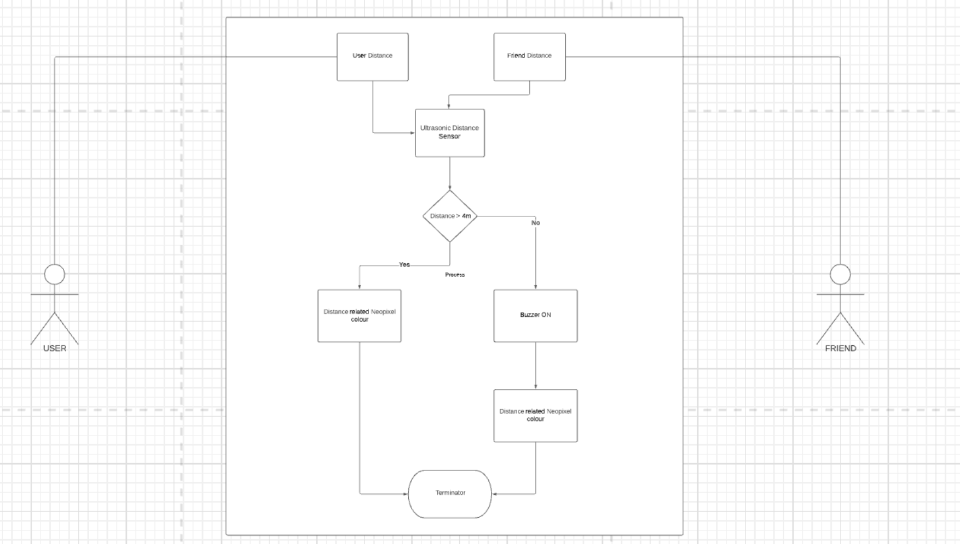

**WORKING MODULES**

To make a social distancing alarm we’re using Arduino Uno, Ultrasonic sensor, Buzzer, and Neo Pixel LED ring. An ultrasonic sensor that has an Echo pin. It is connected to Arduino digital pin number 10 and the Trig is connected to Digital Pin 9. Talking about LEDs, Buzzer Negative is connected Together and buzzer positive wire will be connected to a (D12) pin and LED positive wire will be connected to the (D11) pin. After making all these connections our circuit is ready. Ultrasonic sensors send waves. These waves are absolutely invisible and come back after hitting an optical. The Trig pin activates (D11) Or (D12). In which we have connected LED and Buzzer. We have kept a distance of 100 cm. You can increase this parameter by modifying the code.

In the dashboard, we are showing a video of the Tinkercad simulation as well as showing an animated picture of how our sensor works. We have also added a graph to show the history of distances that the user has come in contact with different people during the day which is stored in a database which can be accessed by the user at any time that they want to.The gauge in the dashboard shows the distance visually for the user.

**DESCRIPTION OF EACH MODULE**

In the flow we are using many different nodes such as:

**MQTT broker node** which aids us in the IOT part of our project by connecting the sensor with the internet and storing the data in a database.

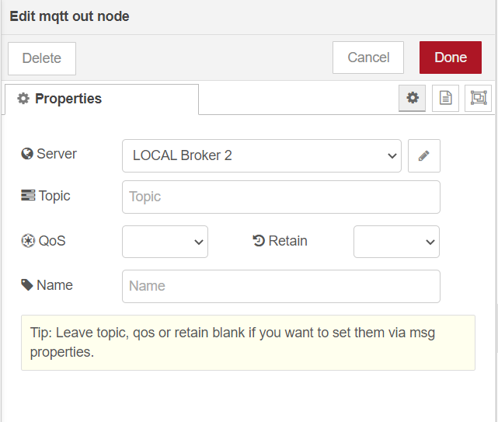

**Random node** which generates a random value between the range 80-500 to simulate the user distance in their daily life.

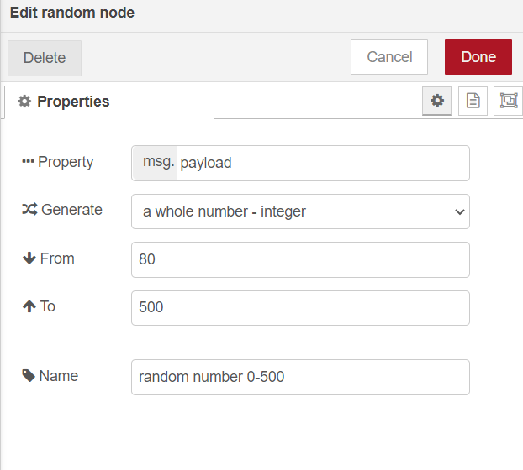

We have used **three different dashboard nodes** to visually represent the user distance generated randomly

**Gauge node** to visually warn the user by using different colours for different distances (Like a Neo pixel ring).

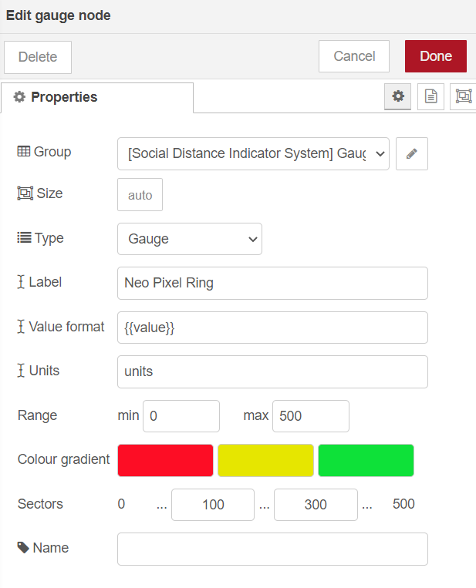

**Chart node** to visually represent the distance graphically and finally a **Text node** that shows the current user distance numerically from the person they are opposite to.

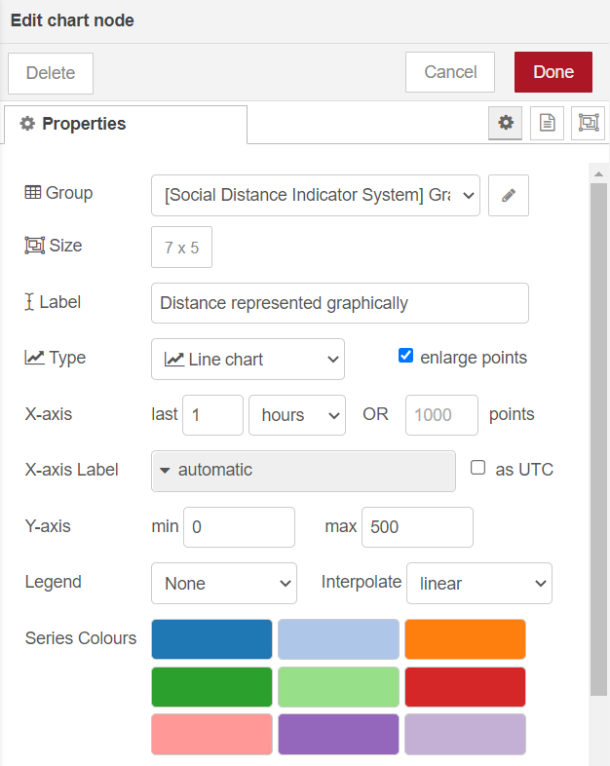

We are using the **Media node** for displaying the Tinkercad simulation as well as for our animated depiction of our project.

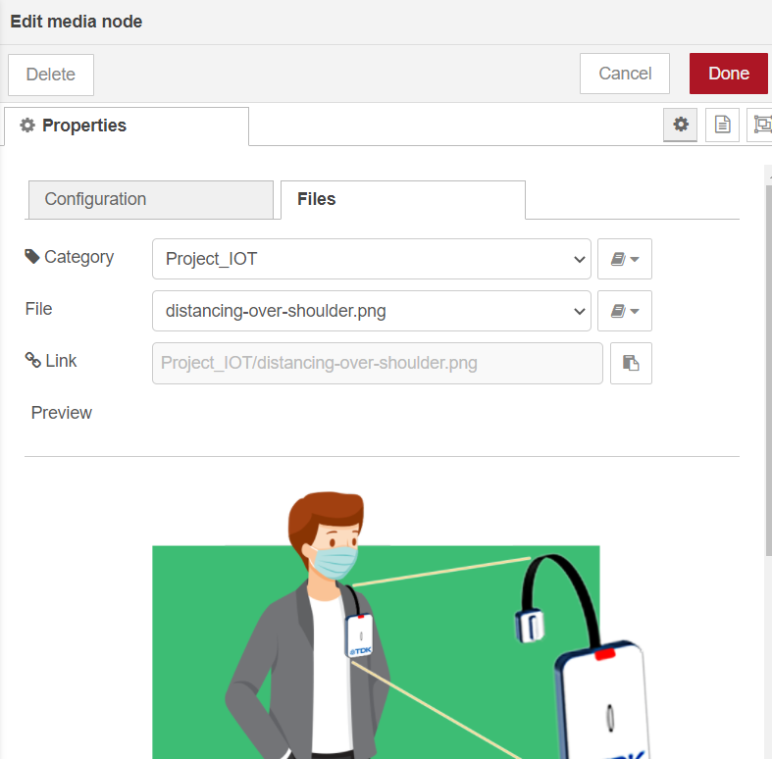

A **Switch node** has been used to set the range of the distances, to classify it as either safe or unsafe distance. We have set the range for safe distance as greater than 150cm. If the value is equal to 100cm, it is considered to be a cautious distance. Any value less than 100cm will be considered as unsafe distance and the user will be warned with an **Audio out node** which says “Too near” (works like a buzzer).

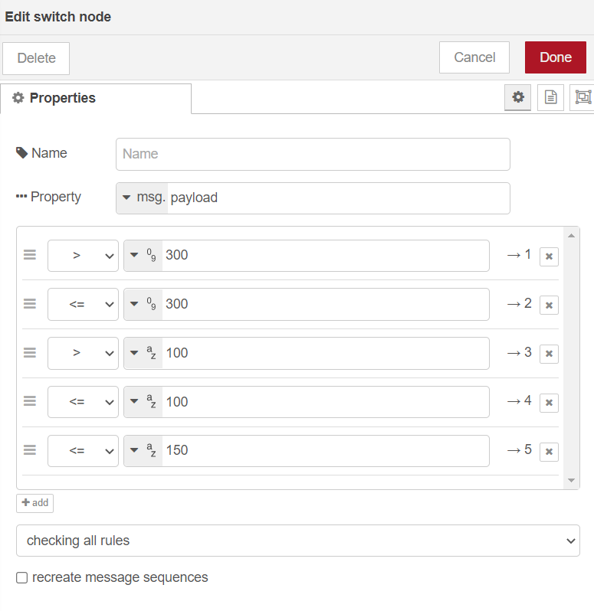

At last we are using a **File node** which saves the user data in a local database from where the user can access it at any time.

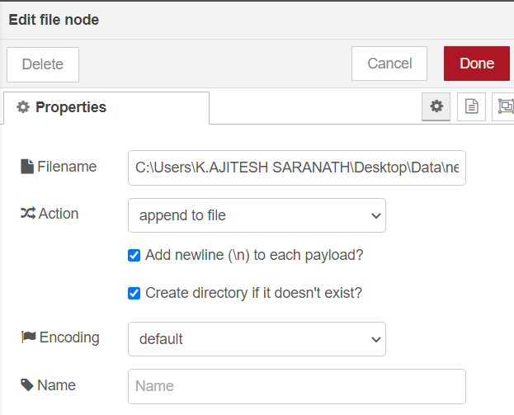

**PROGRAM CODE**

**Tinkercad Simulation Code**

#include <Adafruit_NeoPixel.h>

//for LED ring

int ledPin= 3;

int ledNo= 12;

Adafruit_NeoPixel strip= Adafruit_NeoPixel(ledNo,ledPin,NEO_RGB+NEO_KHZ800);

//length,pin,pixel type

int buzzerPin= 2; //signal pin connected to 2

int echoPin= 6;

int trigPin= 5;

int minDistance = 100; //cm

int maxDistance = 300; //cm

void setup()

{

pinMode(buzzerPin, OUTPUT);

pinMode(trigPin, OUTPUT);//setting it as O/P pin

pinMode(echoPin, INPUT);//setting as I/P pin

Serial. begin(9600);

strip.begin();

for(int i = 0; i < ledNo; i++)

{

strip.setPixelColor(i,strip.Color(0,0,0));

}

strip.show();

}

void loop()

{

int distance = calcDistance();

Serial.println(distance);//print the distance

int ledsToGlow = map(distance, minDistance, maxDistance, ledNo, 1);

//LED will glow

Serial.println(ledsToGlow);

if(ledsToGlow == 12)

{

digitalWrite(buzzerPin, HIGH);//setting buzzer at 1000khz

tone(buzzerPin, 1000);

}

else

{

digitalWrite(buzzerPin, LOW);//0khz

noTone(buzzerPin);

}

for(int i = 0; i < ledsToGlow; i++)

{

if(i < 4)

{

strip.setPixelColor(i,strip.Color(50,0,0));//green,red,blue

}

else if(i >= 4 && i < 8)

{

strip.setPixelColor(i,strip.Color(50,50,0));//green,red,blue

}

else if(i >= 8 && i < 12)

{

strip.setPixelColor(i,strip.Color(0,50,0));//green,red,blue

}

}

for(int i = ledsToGlow; i < ledNo; i++)

{

strip.setPixelColor(i,strip.Color(0,0,0));

}

strip.show();

delay(50);

}

int calcDistance()

{

long distance,duration;

digitalWrite(trigPin, LOW);//O/P as Low

delayMicroseconds(2);//delay

digitalWrite(trigPin, HIGH);//O/P as high

delayMicroseconds(10);//delay

digitalWrite(trigPin, LOW);

duration = pulseIn(echoPin, HIGH);

distance = duration/29/2;//total distance in seconds/2

if(distance >= maxDistance)

{

distance = maxDistance;

}

if(distance <= minDistance)

{

distance = minDistance;

}

return distance;

}

**Node-Red JSON Code**

[

{

"id": "98460b486bad2b7d",

"type": "tab",

"label": "Dashboard",

"disabled": false,

"info": ""

},

{

"id": "15e38061a8222a97",

"type": "inject",

"z": "98460b486bad2b7d",

"name": "Instructions",

"props": [

{

"p": "payload"

},

{

"p": "topic",

"vt": "str"

}

],

"repeat": "",

"crontab": "",

"once": false,

"onceDelay": 0.1,

"topic": "",

"payload": "Use the button to generate random distance.",

"payloadType": "str",

"x": 90,

"y": 40,

"wires": [

[

"9be267b8eb4eac79"

]

]

},

{

"id": "9be267b8eb4eac79",

"type": "ui_text",

"z": "98460b486bad2b7d",

"group": "4447fc3ebd3b719a",

"order": 8,

"width": 0,

"height": 0,

"name": "",

"label": "Use the button to generate random distance.",

"format": "{{msg.payload}}",

"layout": "row-spread",

"x": 390,

"y": 40,

"wires": []

},

{

"id": "3ec088c239ed1c85",

"type": "ui_switch",

"z": "98460b486bad2b7d",

"name": "",

"label": "On / Off",

"tooltip": "",

"group": "4447fc3ebd3b719a",

"order": 9,

"width": 0,

"height": 0,

"passthru": true,

"decouple": "false",

"topic": "topic",

"topicType": "msg",

"style": "",

"onvalue": "true",

"onvalueType": "bool",

"onicon": "fa-arrow-circle-up",

"oncolor": "Green",

"offvalue": "false",

"offvalueType": "bool",

"officon": "fa-arrow-circle-down",

"offcolor": "Red",

"animate": true,

"x": 400,

"y": 120,

"wires": [

[

"cff5a7b6d79a226b"

]

]

},

{

"id": "0d63a9e36a7e0165",

"type": "function",

"z": "98460b486bad2b7d",

"name": "Random #s",

"func": "if (msg.payload === false){\n return null;\n}\nmsg.payload = Math.round(Math.random()*100);\nreturn msg;",

"outputs": 1,

"noerr": 0,

"initialize": "",

"finalize": "",

"libs": [],

"x": 1010,

"y": 180,

"wires": [

[]

]

},

{

"id": "a8485126038a5b72",

"type": "link in",

"z": "98460b486bad2b7d",

"name": "",

"links": [

"c99632e4e4417ebe"

],

"x": 135,

"y": 340,

"wires": [

[

"b509caf517f3b8c8",

"b33a102bf57c1763",

"9d43c41e3db825f9",

"64ca9fffbbe8ef7a",

"645883a3786d6e9c"

]

]

},

{

"id": "c99632e4e4417ebe",

"type": "link out",

"z": "98460b486bad2b7d",

"name": "",

"links": [

"a8485126038a5b72"

],

"x": 815,

"y": 60,

"wires": []

},

{

"id": "b509caf517f3b8c8",

"type": "ui_chart",

"z": "98460b486bad2b7d",

"name": "Distance",

"group": "f871cf280772d4a7",

"order": 10,

"width": "7",

"height": "5",

"label": "Distance represented graphically",

"chartType": "line",

"legend": "false",

"xformat": "auto",

"interpolate": "linear",

"nodata": "",

"dot": true,

"ymin": "0",

"ymax": "500",

"removeOlder": 1,

"removeOlderPoints": "",

"removeOlderUnit": "3600",

"cutout": 0,

"useOneColor": false,

"useUTC": false,

"colors": [

"#1f77b4",

"#aec7e8",

"#ff7f0e",

"#2ca02c",

"#98df8a",

"#d62728",

"#ff9896",

"#9467bd",

"#c5b0d5"

],

"outputs": 1,

"useDifferentColor": false,

"x": 340,

"y": 220,

"wires": [

[

"e72958b2097031dd"

]

]

},

{

"id": "24264f801f96062f",

"type": "function",

"z": "98460b486bad2b7d",

"name": "",

"func": "if (msg.payload === false){\n return null;\n}\nmsg.payload = Math.round(Math.random()*100);\nreturn msg;",

"outputs": 1,

"noerr": 0,

"initialize": "",

"finalize": "",

"libs": [],

"x": 1060,

"y": 240,

"wires": [

[]

]

},

{

"id": "9d43c41e3db825f9",

"type": "switch",

"z": "98460b486bad2b7d",

"name": "",

"property": "payload",

"propertyType": "msg",

"rules": [

{

"t": "gt",

"v": "300",

"vt": "num"

},

{

"t": "lte",

"v": "300",

"vt": "num"

},

{

"t": "gt",

"v": "100",

"vt": "str"

},

{

"t": "lte",

"v": "100",

"vt": "str"

},

{

"t": "lte",

"v": "150",

"vt": "str"

}

],

"checkall": "true",

"repair": false,

"outputs": 5,

"x": 350,

"y": 440,

"wires": [

[

"17d37cab568f8cf9"

],

[

"5082505fb307a416"

],

[

"5082505fb307a416"

],

[

"f2f6e66776fb03cb"

],

[

"f6be4f1068bee51b"

]

]

},

{

"id": "f2f6e66776fb03cb",

"type": "template",

"z": "98460b486bad2b7d",

"name": "Unsafe distance",

"field": "payload",

"fieldType": "msg",

"format": "handlebars",

"syntax": "mustache",

"template": "Caution! Unsafe Distance!Move Away! {{payload}} ",

"output": "str",

"x": 640,

"y": 540,

"wires": [

[

"dba70c716ec46070"

]

]

},

{

"id": "17d37cab568f8cf9",

"type": "template",

"z": "98460b486bad2b7d",

"name": "safe distance ",

"field": "payload",

"fieldType": "msg",

"format": "handlebars",

"syntax": "mustache",

"template": "You are at a safe distance :) {{payload}} ",

"output": "str",

"x": 630,

"y": 380,

"wires": [

[

"dba70c716ec46070"

]

]

},

{

"id": "dba70c716ec46070",

"type": "ui_toast",

"z": "98460b486bad2b7d",

"position": "bottom right",

"displayTime": "1",

"highlight": "teal",

"sendall": true,

"outputs": 0,

"ok": "OK",

"cancel": "",

"raw": false,

"topic": "",

"name": "",

"x": 920,

"y": 440,

"wires": []

},

{

"id": "64ca9fffbbe8ef7a",

"type": "file",

"z": "98460b486bad2b7d",

"name": "",

"filename": "C:\\Users\\K.AJITESH SARANATH\\Desktop\\Data\\new.csv",

"appendNewline": true,

"createDir": true,

"overwriteFile": "false",

"encoding": "none",

"x": 530,

"y": 640,

"wires": [

[]

]

},

{

"id": "cff5a7b6d79a226b",

"type": "random",

"z": "98460b486bad2b7d",

"name": "random number 0-500",

"low": "80",

"high": "500",

"inte": "true",

"property": "payload",

"x": 660,

"y": 180,

"wires": [

[

"ec65309a3c7ff8fd",

"c99632e4e4417ebe"

]

]

},

{

"id": "b33a102bf57c1763",

"type": "ui_text",

"z": "98460b486bad2b7d",

"group": "f871cf280772d4a7",

"order": 11,

"width": 0,

"height": 0,

"name": "DISTANCE",

"label": "Distance is currently",

"format": "{{msg.payload}}",

"layout": "row-spread",

"x": 350,

"y": 340,

"wires": []

},

{

"id": "e72958b2097031dd",

"type": "ui_media",

"z": "98460b486bad2b7d",

"group": "a56c58d0649afe34",

"name": "",

"width": "6",

"height": "4",

"order": 5,

"category": "Project_IOT",

"file": "distancing-over-shoulder.png",

"layout": "adjust",

"showcontrols": true,

"loop": true,

"onstart": false,

"scope": "local",

"tooltip": "",

"x": 590,

"y": 240,

"wires": [

[

"d607eecdb7059f0d"

]

]

},

{

"id": "603d8f1cf0c094cb",

"type": "inject",

"z": "98460b486bad2b7d",

"name": "",

"props": [

{

"p": "payload"

},

{

"p": "topic",

"vt": "str"

}

],

"repeat": "",

"crontab": "",

"once": true,

"onceDelay": "3",

"topic": "",

"payloadType": "str",

"x": 110,

"y": 120,

"wires": [

[

"3ec088c239ed1c85",

"27f7c285edc771df"

]

]

},

{

"id": "5085b806134edba5",

"type": "mqtt in",

"z": "98460b486bad2b7d",

"name": "",

"topic": "Receiver",

"qos": "2",

"datatype": "auto",

"broker": "b523e7d2bfa3330e",

"nl": false,

"rap": true,

"rh": 0,

"x": 100,

"y": 400,

"wires": [

[

"b509caf517f3b8c8",

"b33a102bf57c1763",

"9d43c41e3db825f9",

"64ca9fffbbe8ef7a"

]

]

},

{

"id": "ec65309a3c7ff8fd",

"type": "mqtt out",

"z": "98460b486bad2b7d",

"name": "",

"topic": "",

"qos": "",

"retain": "",

"respTopic": "",

"contentType": "",

"userProps": "",

"correl": "",

"expiry": "",

"broker": "b523e7d2bfa3330e",

"x": 870,

"y": 120,

"wires": []

},

{

"id": "027dcfafc0849f93",

"type": "aedes broker",

"z": "98460b486bad2b7d",

"name": "localbroker 2",

"mqtt_port": 1883,

"mqtt_ws_bind": "port",

"mqtt_ws_port": "",

"mqtt_ws_path": "",

"cert": "",

"key": "",

"certname": "",

"keyname": "",

"dburl": "",

"usetls": false,

"x": 580,

"y": 80,

"wires": [

[]

]

},

{

"id": "645883a3786d6e9c",

"type": "ui_gauge",

"z": "98460b486bad2b7d",

"name": "",

"group": "faee651240e0f383",

"order": 1,

"width": 0,

"height": 0,

"gtype": "gage",

"title": "Neo Pixel Ring ",

"label": "units",

"format": "{{value}}",

"min": "0",

"max": "500",

"colors": [

"#fd0d25",

"#e6e600",

"#0ee139"

],

"seg1": "100",

"seg2": "300",

"x": 270,

"y": 180,

"wires": []

},

{

"id": "27f7c285edc771df",

"type": "debug",

"z": "98460b486bad2b7d",

"name": "",

"active": false,

"tosidebar": true,

"console": false,

"tostatus": false,

"complete": "payload",

"targetType": "msg",

"statusVal": "",

"statusType": "auto",

"x": 130,

"y": 240,

"wires": []

},

{

"id": "5082505fb307a416",

"type": "template",

"z": "98460b486bad2b7d",

"name": "Caution",

"field": "payload",

"fieldType": "msg",

"format": "handlebars",

"syntax": "mustache",

"template": "Be Cautious!You are too near! {{payload}} ",

"output": "str",

"x": 630,

"y": 460,

"wires": [

[

"dba70c716ec46070"

]

]

},

{

"id": "d607eecdb7059f0d",

"type": "ui_media",

"z": "98460b486bad2b7d",

"group": "91413fe4b12434b8",

"name": "",

"width": 0,

"height": 0,

"order": 0,

"category": "Project_IOT_Video",

"file": "Proje.mp4",

"layout": "adjust",

"showcontrols": true,

"loop": true,

"onstart": false,

"scope": "local",

"tooltip": "",

"x": 720,

"y": 300,

"wires": [

[

"b603decd951eeac6"

]

]

},

{

"id": "b603decd951eeac6",

"type": "ui_media",

"z": "98460b486bad2b7d",

"group": "012f17bd060d56fe",

"name": "",

"width": "6",

"height": "5",

"order": 0,

"category": "Project_Tinkercad",

"file": "Capture.JPG",

"layout": "adjust",

"showcontrols": true,

"loop": true,

"onstart": false,

"scope": "local",

"tooltip": "",

"x": 900,

"y": 340,

"wires": [

[]

]

},

{

"id": "e90f77b260292abb",

"type": "ui_audio",

"z": "98460b486bad2b7d",

"name": "",

"group": "a56c58d0649afe34",

"voice": "Microsoft David - English (United States)",

"always": "",

"x": 870,

"y": 540,

"wires": []

},

{

"id": "f6be4f1068bee51b",

"type": "template",

"z": "98460b486bad2b7d",

"name": "",

"field": "payload",

"fieldType": "msg",

"format": "handlebars",

"syntax": "mustache",

"template": "Danger!You are too near!",

"output": "str",

"x": 650,

"y": 600,

"wires": [

[

"e90f77b260292abb"

]

]

},

{

"id": "4447fc3ebd3b719a",

"type": "ui_group",

"name": "Start / Stop",

"tab": "8b887b05c06070ee",

"order": 3,

"disp": true,

"width": "6",

"collapse": false

},

{

"id": "f871cf280772d4a7",

"type": "ui_group",

"name": "Graph",

"tab": "8b887b05c06070ee",

"order": 2,

"disp": true,

"width": "7",

"collapse": false

},

{

"id": "a56c58d0649afe34",

"type": "ui_group",

"name": "Practical Application (Animation)",

"tab": "8b887b05c06070ee",

"order": 1,

"disp": true,

"width": "6",

"collapse": false

},

{

"id": "b523e7d2bfa3330e",

"type": "mqtt-broker",

"name": "LOCAL Broker 2",

"broker": "localhost",

"port": "1883",

"clientid": "",

"usetls": false,

"protocolVersion": "4",

"keepalive": "60",

"cleansession": true,

"birthTopic": "",

"birthQos": "0",

"birthPayload": "",

"birthMsg": {},

"closeTopic": "",

"closeQos": "0",

"closePayload": "",

"closeMsg": {},

"willTopic": "",

"willQos": "0",

"willPayload": "",

"willMsg": {},

"sessionExpiry": ""

},

{

"id": "faee651240e0f383",

"type": "ui_group",

"name": "Gauge",

"tab": "8b887b05c06070ee",

"order": 4,

"disp": true,

"width": "6",

"collapse": false

},

{

"id": "91413fe4b12434b8",

"type": "ui_group",

"name": "Tinkercad Simulation",

"tab": "8b887b05c06070ee",

"order": 5,

"disp": true,

"width": "6",

"collapse": false

},

{

"id": "012f17bd060d56fe",

"type": "ui_group",

"name": "Tinkercad Representation",

"tab": "8b887b05c06070ee",

"order": 6,

"disp": true,

"width": "6",

"collapse": false

},

{

"id": "8b887b05c06070ee",

"type": "ui_tab",

"name": "Social Distance Indicator System",

"icon": "dashboard",

"disabled": false,

"hidden": false

}

]

**OUTPUT**

**Tinkercad Simulation**

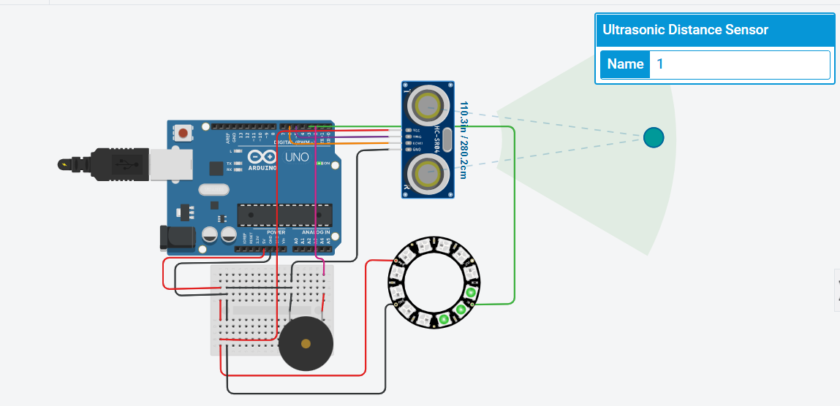

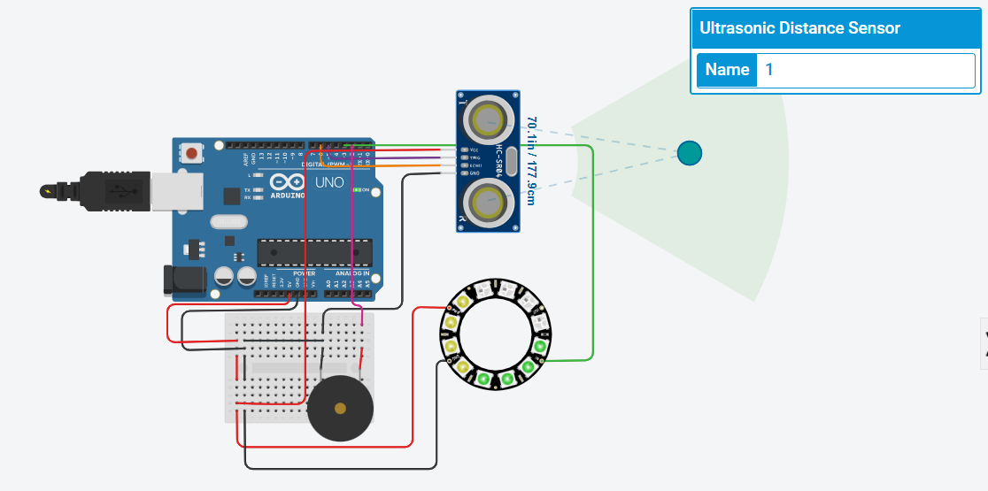

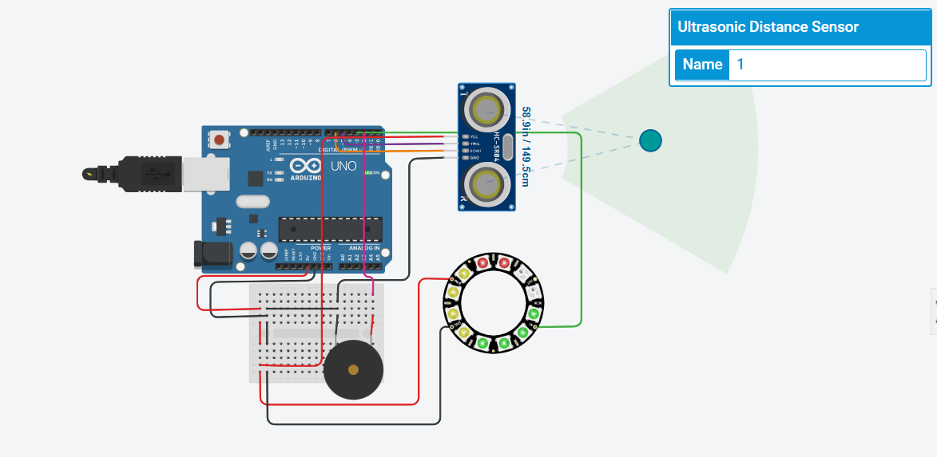

**Node Red Flow**

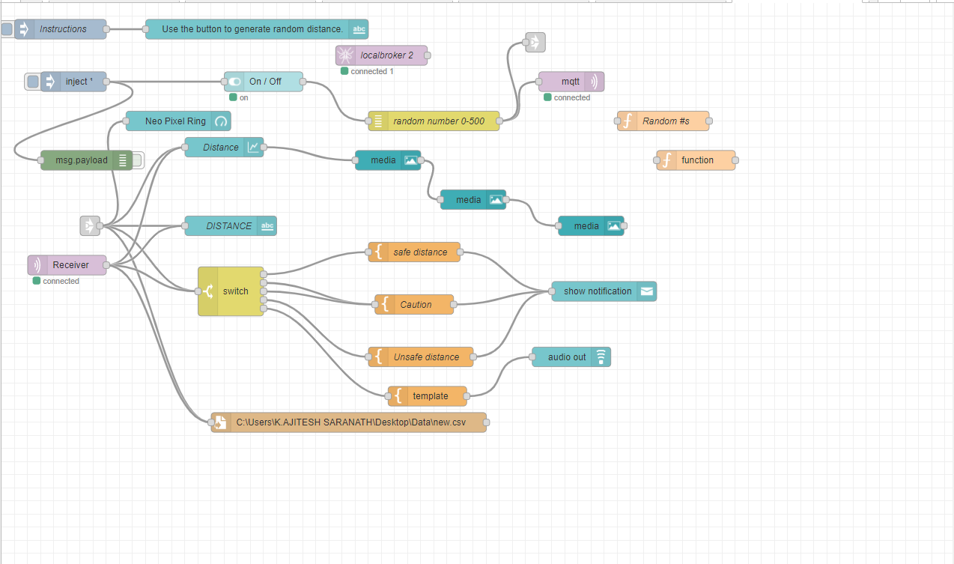

**Node Red Dashboard**

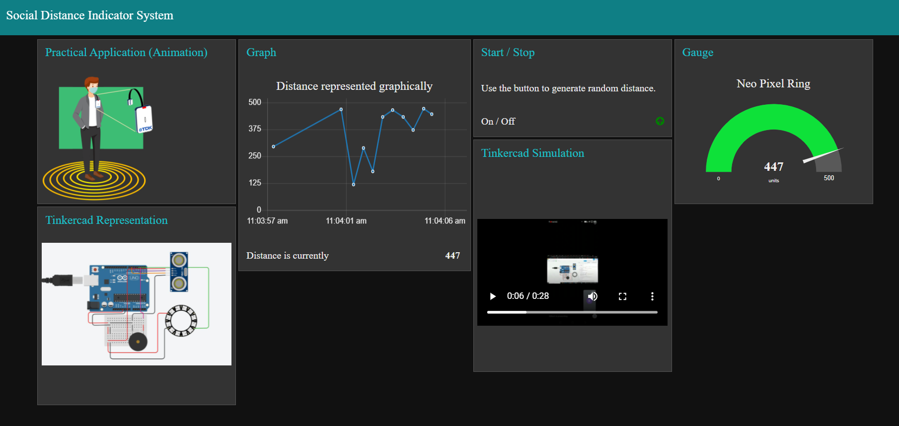

**CONCLUSION**

This project gives an insight on the importance of social distancing in present times. The node-red dashboard shows the user graphically the distance that they maintained and as well as stores the user data in a dataset which can be accessed by the user at any time. Maintaining these essential norms can be a key factor in reducing the spread of the disease.

**FUTURE WORKS**

This project can be modified in several ways to make it more efficient. All the features mentioned in this project are to be implemented hardware wise.

We aim to work more on the sensor features such that it enables entire 360 degree coverage.

Some of these can be fixed by:

* A better 3D casing system.
* Changing to a better sensor to detect only humans and not other objects.

**REFERENCES**

[1] Roosa K, Lee Y, Luo R, Kirpich A, Rothenberg R, Hyman JM, et al. Short-term forecasts of the COVID-19 epidemic in Guangdong and Zhejiang, China: February 13–23, 2020. Journal of clinical medicine. 2020;9(2):596. Pmid:32098289.

[2] Eksin C, Paarporn K, Weitz JS. Systematic biases in disease forecasting–The role of behavior change. Epidemics. 2019;27:96–105. Pmid:30922858.

[3] Adolph C, Amano K, Bang-Jensen B, Fullman N, Wilkerson J. Pandemic politics: Timing state-level social distancing responses to COVID-19. medRxiv. 2020.

[4] WHO. Who director-generals opening remarks at the media briefing on covid-19-11 march 2020;.